

**Learning disability core skills education and training framework**

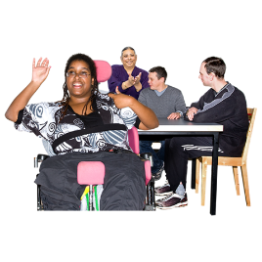

**Tell us what you think.**



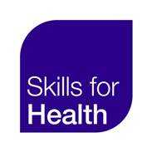**This consultation closes on the 20th of March 2019**



**What is the learning disability core skills education and training framework?**



It is a list of all the things we think health and social care staff should know about working with people with a learning disability.

It is split into 3 levels, called tiers.

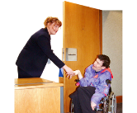

Tier 1 is for everyone who may sometimes have to meet a person with a learning disability   
  
  
The kinds of people who may need   
Tier 1 training include people like receptionists, hospital porters,   
or admin staff from any organisation.

**1**



Sometimes people call this training, learning disability awareness.

Tier 2 is for health and social care staff and others who give some care and support for a person or people with a learning disability.

**2**



The kinds of people who may need Tier 2 training include personal assistants, some support workers, some nurses, and some doctors.

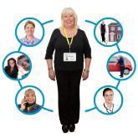

Tier 3 training is for people who make lots of decisions about care and support for people with a learning disability.

**3**



Tier 3 workers may support other health and social care workers to know what to do.



It may be for people who run services for people with a learning disability, like a supported living service manager.

It may be for people who make choices about care and support for people with a learning disability, like a learning disability GP, or a learning disability nurse.



**People trained to Tier 1 level should understand some important things about learning disability:**



They should understand what it means to have a learning disability.



Know some of the things that may cause a learning disability

  
Know it is important to find out about a person’s learning disability and support needs early

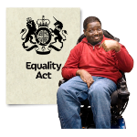

Know about some the main laws that protect the rights of people with a learning disability, like the Equality Act and Mental Capacity Act.



Know about the history of services for people with a learning disability and how they are changing to be more person centred.



**People trained to Tier 1 should understand how make sure care and support is person centred**

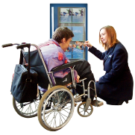

They should be able to make simple changes to the way they communicate to make it easier for people with a learning disability.



  
Understand how to get more support to help them communicate with a person.

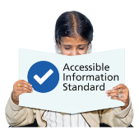

Understand what the Accessible Information Standard means for them and their organisation.



Know about some of the barriers faced by people with a learning disability and their families and carers



Understand how family carers and support workers can help a person with a learning disability.

**Tier 1 workers should know how to support people with a learning disability with their health and wellbeing:**

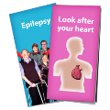

They should know about how these conditions and how they may affect people with a learning disability:

|  |  |  |
| --- | --- | --- |
| **Epilepsy** | **Trauma** | **Sepsis** |
| **Diabetes** | **Dysphagia** | **Constipation** |
| **Bowel cancer** | **Heart disease** |  |



They should know how to spot the signs of these conditions in people with a learning disability.

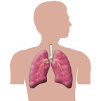They should understand that people with a learning disability have a high risk of choking and breathing problems.



They should understand that sometimes people show pain or illness through a change in their behaviour.



They should understand why people with a learning disability can have problems getting the healthcare they need.

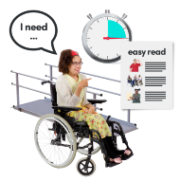  
They should know about common reasonable adjustments that may help people with a learning disability to access healthcare services.

  
  
They should know about health action plans and hospital passports.

  
They should know about the kinds of support people with a learning disability may need when things change in their lives.



Understand how other people’s views and attitudes can affect people with a learning disability and their families.

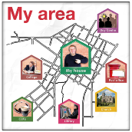

Know where people with a learning disability and their families can get more support in the community.



Know where they can get extra support to give people with a learning disability the right care.

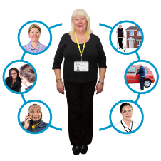

Understand why it is so important that care is joined up for people with high or complex needs.

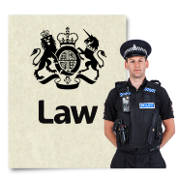

**The law and keeping people safe**

 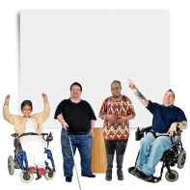

They should know why it is important to make sure people with a learning disability have equal rights.



They should understand what advocacy is and how it can help.

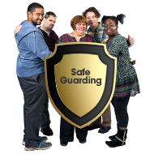

They should know how people can work together to stop abuse and neglect and keep people safe.



They should know about disability hate crime and how to report it.

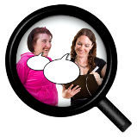 **Our questions:**

**You can tell us what you think on your own or as a group**

1. What do you think about our ideas for   
    Tier 1 learning disability awareness training?

  
2. Are these the right things for learning disability awareness training to cover?

  
 3. Is there anything missing from our list?

  
  
  
  
  
  
  
  
  
  
  
  
  
4. Is there anything that should not be in the list?

5. How should people learn Tier 1   
learning disability awareness training? Who should teach them?



  
6. Is there anything else you would like to say about Tier 1 learning disability awareness training?

7. Your name (s)



8. An email address where we can contact you:

  
9. Are you a person with a learning disability?

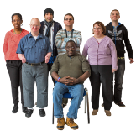10. Are you a group of people with a learning disability?

  
11. Do you have experience providing learning disability awareness training?

12. Is there anything else you would like to tell us about training?

**3**

Tier 2 and Tier 3 training builds on what people have learned at Tier 1.

**1**

**2**



We also want to know what you think people should learn at Tier 2 and 3.

**3**

**2**

13. Tell us what you think here:

If you want to find out more about Tier 2 and Tier 3, or the rest of the Learning Disability Core Skills Education and Training Framework ask us.

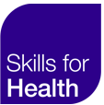

Send your responses to Colin and Hilary at Skills for Health



Email:

[colin.wright@wdtrust.org.uk](mailto:colin.wright@wdtrust.org.uk)

[hilary.wyles@wdtrust.org.uk](mailto:hilary.wyles@wdtrust.org.uk)

  
Post:   
Colin Wright & Hilary Wyles  
Skills for Health,   
9th Floor   
Lynton House,   
Tavistock Square,   
London,   
WC1H 9LT